**Master Functional Document**

|  |  |
| --- | --- |
| **Application** | NGERP - Centra |
| **Service Bundle** | Master Management |
| **Service Request** | Group Of Attributes |

**Description:**

Group of Attributes in Compiere (NGERP - Centra) helps categorize and manage business partner details, including customer status, partner group, and unique identifiers, streamlining operations across branches or companies.

**Workflow Process:**

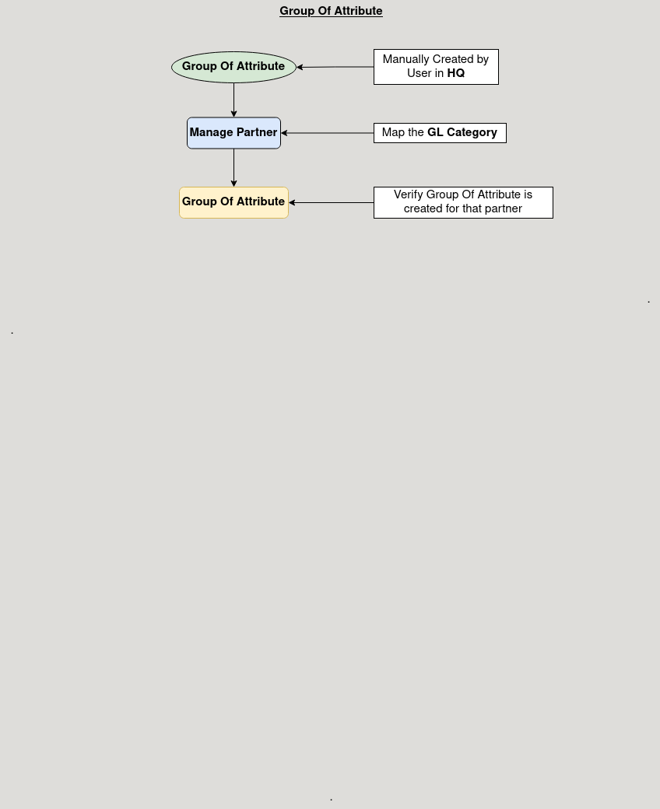

**Business Rules:**

* It is visible in both **HQ** and **ROW.**
* **Creation** is possible only in **HQ.**
* Active status determines whether the record is available for use.
* Search Key allows fast access to specific records using a unique identifier.
* Partner Group classifies business partners into different categories.
* Customer checkbox indicates if the business partner is a customer, unlocking additional fields.
* BP Group Type differentiates between types of business partners (e.g., AP Trade, Non-Trade Vendor).